DrmPad keyboard and menues.

Keyboard layout:

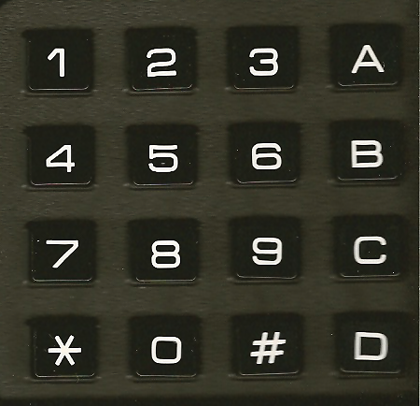

Wanted functions:

Patches.
Channel setup.

Display layout:

2*16 tkn:

A | B | C | D | E | F | G | H | I | J | K | L | M | N | O | P
1 | 2 | 3 | 4 | 5 | 6 | 7 | 8 | 9 | * | # | - | / | = | + | _

Main:

* | * | * |  | D | r | u | m |  | P | a | d |  | * | * | *
 | * | - | H | e | l | p |  |  | # | - | M | e | n | u

Help:

* | - | E | x | i | t | / | P | r | e | v | i | o | u | s
# | - | E | n | t | e | r | / | N | e | x | t |  |  | # | *

Menu:

1 | - | S | o | u | n | d | s |  | 2 | - | C | h | a | n | .
3 | - | P | a | t | c | h | e | s |  |  |  | 1 | 2 | 3 | *

1-Sounds:

 |  | P | a | d | : | _
S | o | u | n | d | : | _ |  |  |  |  | 0 | - | 9 | # | *

2-Channel:

C | h | a | n | n | e | l | : | _
 |  |  |  |  |  |  |  |  |  |  | 0 | - | 9 | # | *

3-Patches:

P | a | t | c | h | : | _
 |  |  |  |  |  |  |  |  |  |  | 0 | - | 9 | # | *

Confirm:

S | a | v | e |  | c | h | a | n | g | e | s | ?
# | - | Y | e | s |  | * | - | N | o |  |  |  |  | # | *

Confirm:

< | n | a | m | e | >
E | d | i | t |  | n | a | m | e | ? |  |  |  |  | # | *

